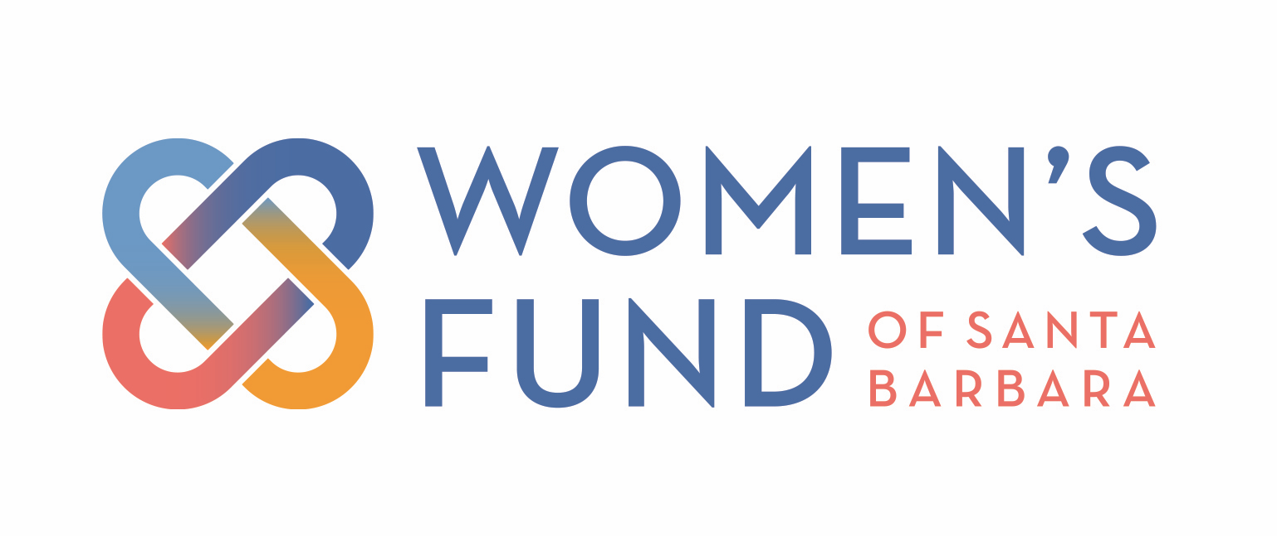
2021-2022 Grantee Year-End Report Summary
Submitted July 2023

Channel Islands YMCA ($75,000 - expended)
New Facility for Street Outreach Services for Youth

The Transitional Youth Navigation Center opened in February 2023 and is the only place in Santa Barbara where transitional aged youth can get all of their basic needs met in one sitting - supplies, showers, laundry, and case management. Seventy-four individuals have been served since opening, and the YMCA anticipates 150 youth being served by end of year. The YMCA leveraged the Women’s Fund grant for a matching donation drive, securing key donations to bring this new facility to fruition.

DignityMoves ($75,000 - expended)
Case Management Office for Interim Housing Community

As of May 17, 2023, Dignity Moves had provided Interim Supportive Housing to 58 unsheltered people and anticipated that approximately 70 would be served at the end of the first year of operations. They are happy to report that during this first year, the point in time count for unsheltered people was down 3% as a result of their village on Santa Barbara Street. They state that the Women’s Fund has helped them raise additional funding: “The Women’s Fund is known for its rigorous research. It is a huge ‘stamp’ of approval that other funders respect.”

Foodbank of Santa Barbara County ($55,000 - expended)
Home Delivery of Groceries to Seniors

During the grant period, Foodbank met its goals by providing 1,780 unduplicated seniors with 446,244 pounds of accessible, culturally relevant foods and bilingual (Spanish-English) nutrition information. Food items were appropriate for their diets (high in protein, low in sodium and saturated fat) and easy to open and prepare. This spring, Foodbank staff hosted cooking classes to provide seniors with the nutritional knowledge and cooking skills to empower them to take proactive control of their health through diet and lifestyle choices. They plan to continue expanding services to meet the needs of older adults and are currently researching options for delivering prepared meals.

Freedom 4 Youth ($100,000/2 Years - $50,000 remaining)
Fem-powerment Program for Girls in the Juvenile Legal Systemm

Freedom 4 Youth reports they have fulfilled the first-year goals listed in their proposal. Over the past year, the agency served 29 girls in the Fem-Powerment group, supported an additional 14 with intensive case management, and provided programming and supportive services to another 54 young women. Overall, 97 unique individuals have received gender-specific services. Freedom 4 Youth’s Executive Director reports that when they applied to the Women’s Fund, their annual budget was around $180k; they are now close to $1 million and raised over $840k in 2023. The organization has grown from two employees to nine.

Girls Inc. of Carpinteria ($100,000/2 Years - $50,000 remaining)
On-Campus Mental Wellness Program

This grant was awarded to pay for a two-year, part-time contract for a licensed therapist to provide weekly therapy sessions for girls and quarterly workshops for parents. Due to hiring challenges, the therapeutic services were provided by in-house Girls Inc. staff, rather than an outside therapist. They anticipate expending the remaining $50,000 by the end of FY23-24 in partnership with Carpinteria Children’s Project to hire one therapist at a higher salary to manage a caseload of 25-30 youth across both agencies. Despite staffing challenges, the program has received broad community support - partnership with Carpinteria Children’s Project, the City of Carpinteria’s launch of Carp Cares for Mental Health program, and positive press. The agency reports that in the first year of the grant, 103 unduplicated girls ages 5-14 benefited from their expanded on-campus mental health program.

People’s Self-Help Housing ($40,000 - $19,470 of grant remaining)
College Club

PSHH served 46 students through their College Club program, just short of their initial goal. However, most of the students were in lower high school grades and did not require as high a level of service as seniors and college students, who are actively applying to and attending college. Because of this, $19,470 of the Women’s Fund grant has not been used. PSHH would appreciate a one-year extension to use the remaining funds for resources for their current students as they reach higher grade levels and in serving new recruits next school year. They successfully engaged students earlier in their high school career and have taken all students off the waitlist because of support from the Women’s Fund grant and other revenue sources.

Sanctuary Centers of Santa Barbara ($100,000 - expended)
Mental Health Integrated Care Clinic Serving Youth

Sanctuary Centers successfully utilized the full Women’s Fund grant to hire two full-time, bilingual licensed therapists to provide free behavioral health services to children and adolescents. Two hundred twenty-four youth clients and their families have been supported by this grant, and additional funding from other philanthropic sources has been secured to continue this program. Critical psychotherapy and psychiatric services for youth hosted by the Department of Behavioral Wellness has a waitlist of 12-24 months; in contrast, with the hiring of two therapists, Sanctuary has decreased the average wait time for youth to seven to ten business days. The Women’s Fund grant has not only provided crucial support for youth and adolescents but has helped leverage new working partnerships between Sanctuary Center, Girls Inc., and Storyteller Children’s Center.

Santa Barbara Education Foundation ($100,000 - expended)
(For Harding University Partnership School)
Outdoor Learning Environment for Pre-school and Elementary Students

The Outdoor Classroom was completed as of June 16, 2023 and has “transformed the learning environment for [Harding’s] youngest students.” The total cost of the completed project was $395,346; the Women’s Fund was a founding donor providing 25.29% of the complete cost. Harding anticipates the Outdoor Classroom will reach 271 individuals (250 PK-2nd grade students, 11 teachers, and 10 support staff) annually. This project has inspired the transformation of another play area for which the school district has already begun engagement via funding of a landscape architect, plants, and a fence.

Santa Barbara Neighborhood Clinics ($100,000 - expended)
Mobile Dental Clinic

As of the report submission, the mobile dental unit was expected to be completed by June 30 and launched for service in September to coincide with the beginning of the school year. The Women’s Fund grant covered 67% of the total cost of the project, with the remaining $50,000 costs for equipment and final upgrades provided by a private donor. The dental clinic is anticipated to provide services for 9,000 - 12,000 unique students in the first year of operation, with potential growth to serve 16,000+ students across Santa Barbara and Goleta school districts.

SB ACT ($100,000 - expended)
Neighborhood Navigation Centers

Since receiving the Women’s Fund grant, SB ACT has served more than 360 unduplicated individuals and families through its Neighborhood Navigation Centers. More than 65 individuals exited street-level homelessness, while hundreds more were connected to case managers and other services to help them progress toward housing and stability. The NNCs are currently the only centralized hub for homelessness services in the City of Santa Barbara. A challenge has been resistance from individual city departments to providing services in public spaces. SB ACT has secured funding from the City of Santa Barbara to help continue the NNCs and the city is now working with them to identify and vet a building that would provide the agency a permanent indoor setting for NNCs that would be open five days per week.

Storyteller Children’s Center ($55,000 - $1,350 of grant remaining)
Family Advocate Program

The Women’s Fund grant supported Storyteller’s Family Advocacy Program for families facing challenges related to mental and behavioral health access, basic needs, finances, housing, legal matters, and more. An on-site Family Advocate contracted through Family Service Agency averages 30 hours per week meeting with parents/guardians/families. In the past year, 120 families were served, impacting the lives of roughly 480 people. Having acquired what was formerly the Transition House Infant Care Center, Storyteller is now partnering with Transition House to provide free childcare on-site during monthly in-person parenting classes and meetings. They are evolving the Family Advocacy Program to create more accessible and expanded services through the Infant and Early Childhood Mental Health Consultation and Family Advocacy Program. Remaining grant funds will be expended at resource fair and educational presentation for families in July.

